What are functional interfaces?
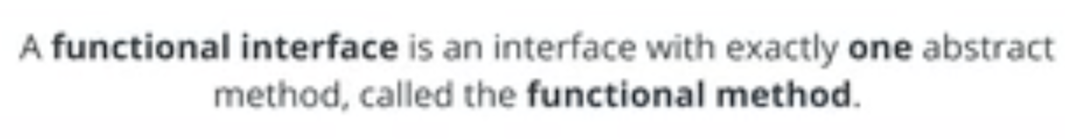

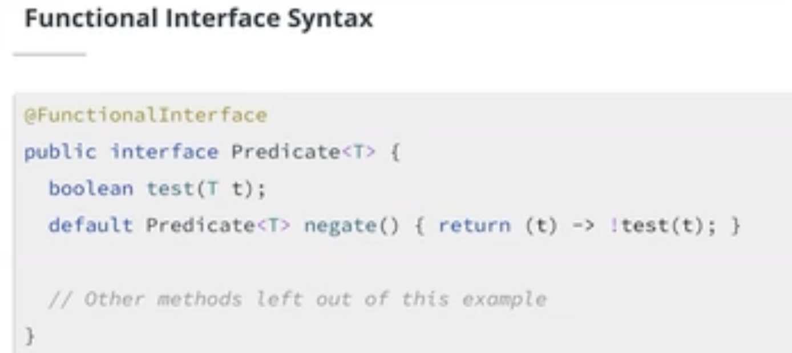
- Top:
- Allowed to have type parameter

- Abstract method here = test = functional method
- Abstract = method is not implemented
  - To be a functional method = Cannot have a default implementation
- Functional interface can have other default methods

- Functional method

- annotaion

- 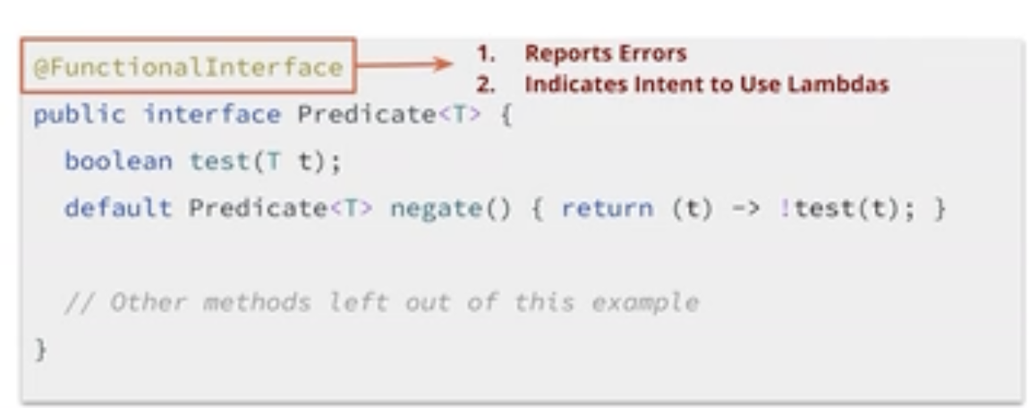
- Functional interface is designed to be used with lambdas

When do we use functional interfaces?
- Functional interface can be target & implemented by lambda expressions
- SHould make it functional interface if it’s describing a single operation
- See: use ppl’s API, see functional interface → used with Lambdas

- Functional interfaces are allowed to have type parameters, and the function method (apply in this case) can take any number of parameters.

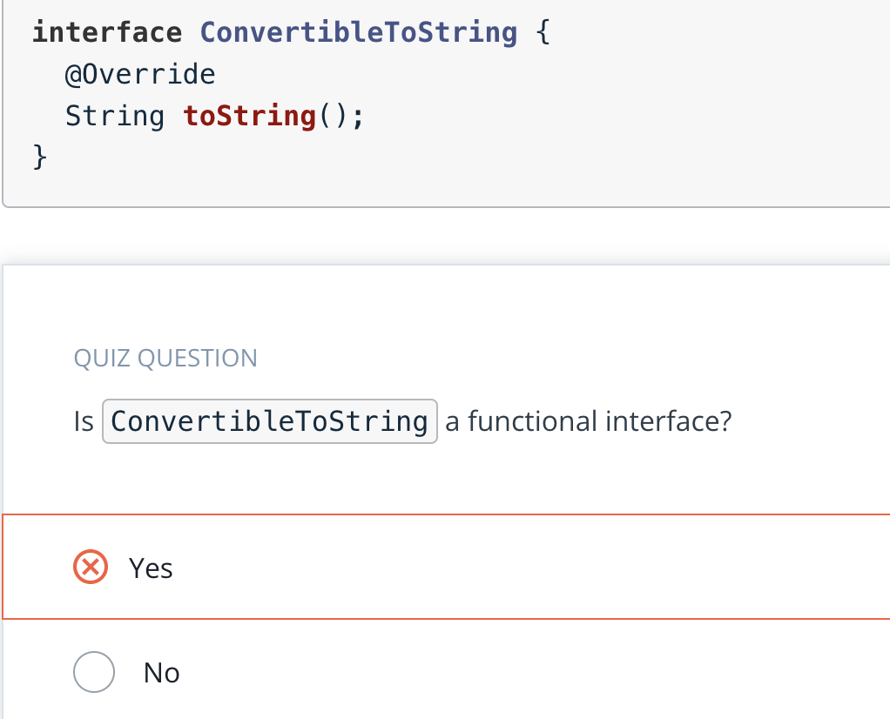
Remember that toString() is declared by java.lang.Object.

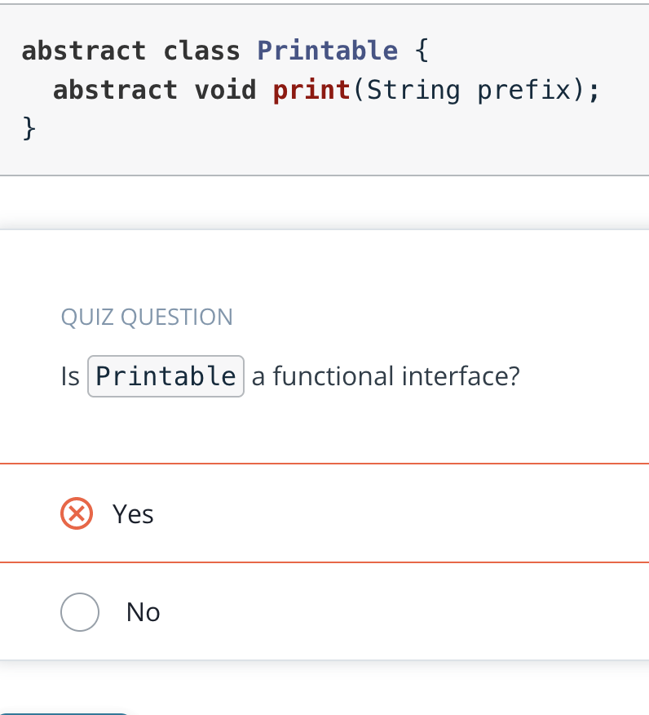
Remember, functional interfaces are interfaces, not classes

Anonymous subclasses
What is lambda?
- Convenient way to implement functional interfaces
- 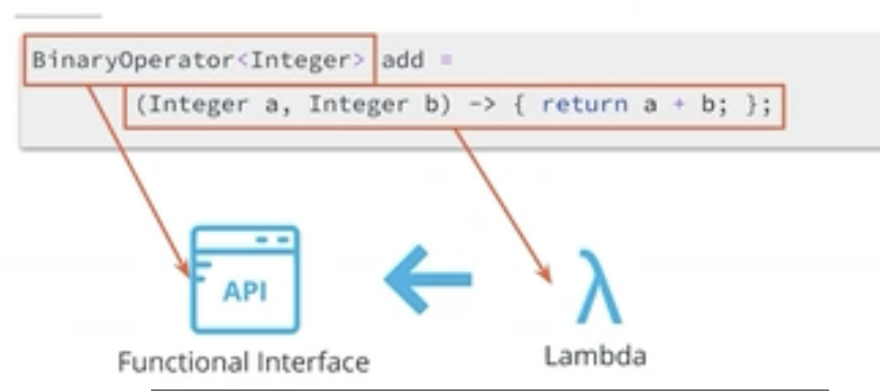
- Both anonymous class & lamda can be used top implmement functioan linterfaces

What is a anonymous clas?
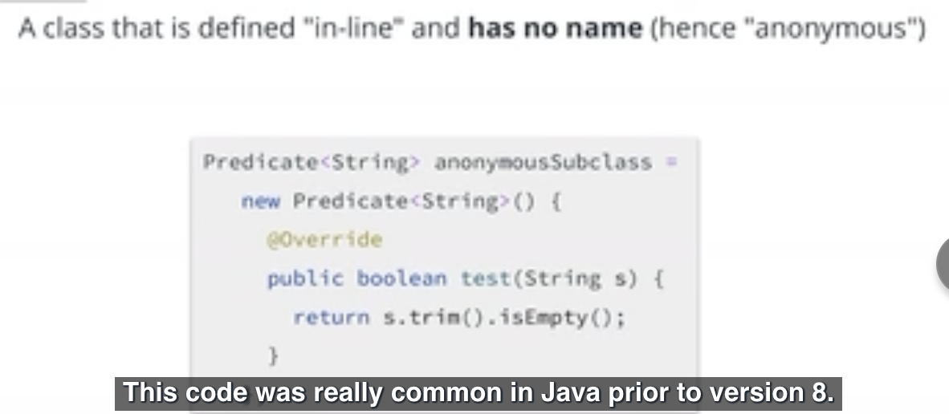
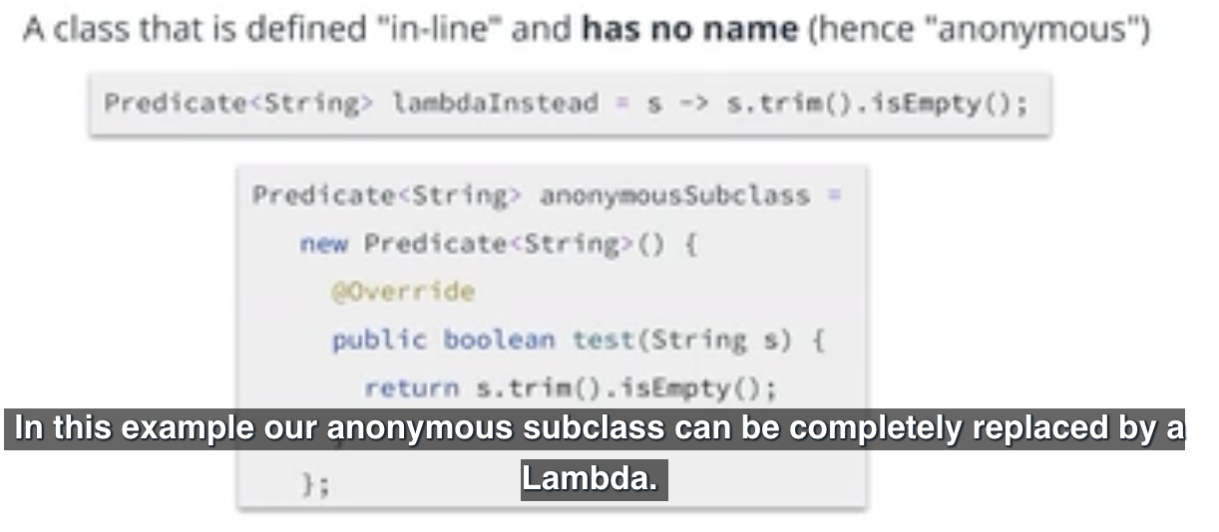

WHen will we be forces to use anonymous classes?

Is it object/ classes that implements interfaces?

Questions:

Even though anonymous classes do not have their own name, they can still have an identity defined by equals() and hashCode().

What’s enclosing class?

Limitation of Lambdas

- Throwing Exceptions

Method References

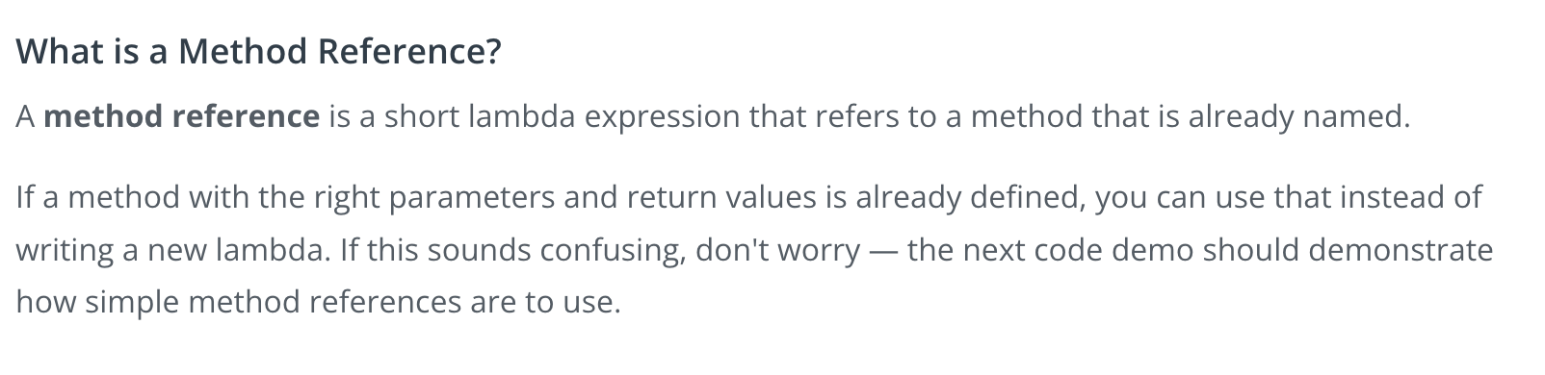

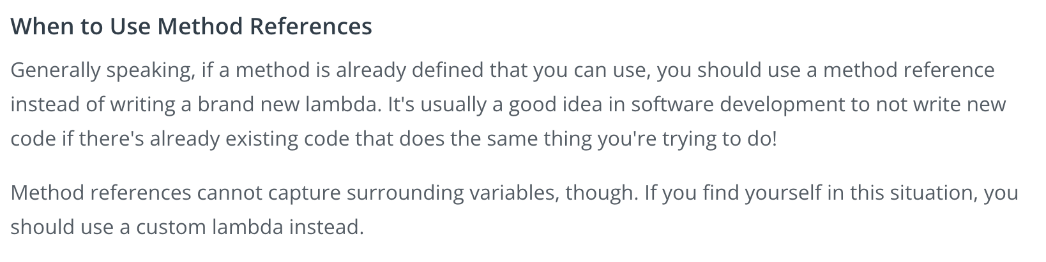

Quiz:
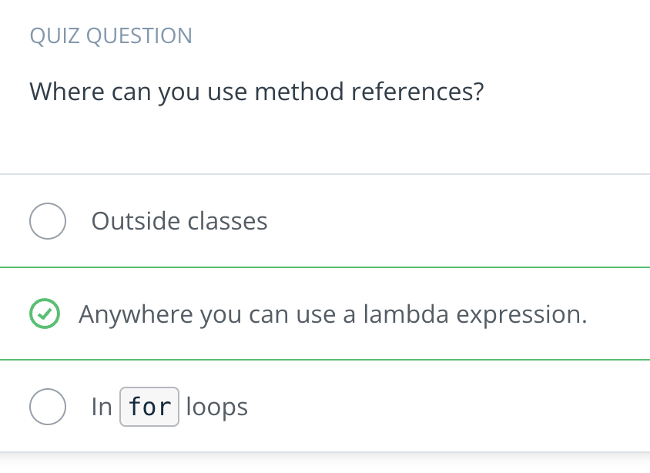
Right. Method references are a kind of lambda expression.

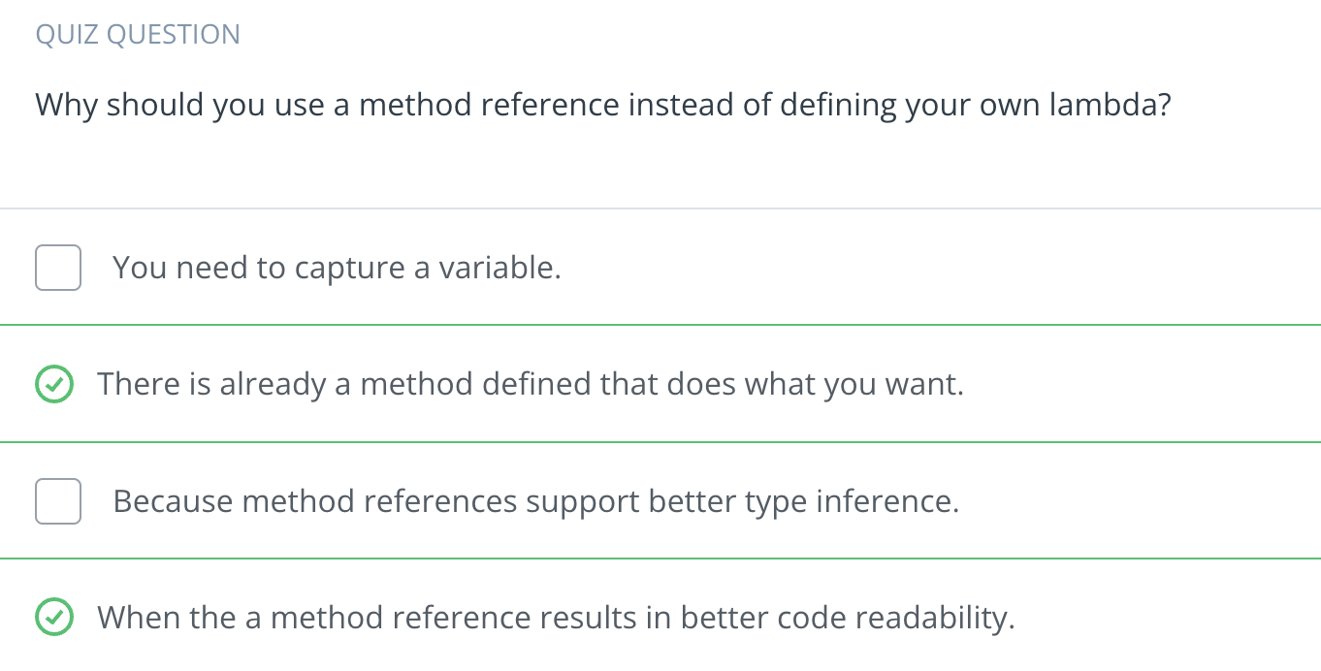
- 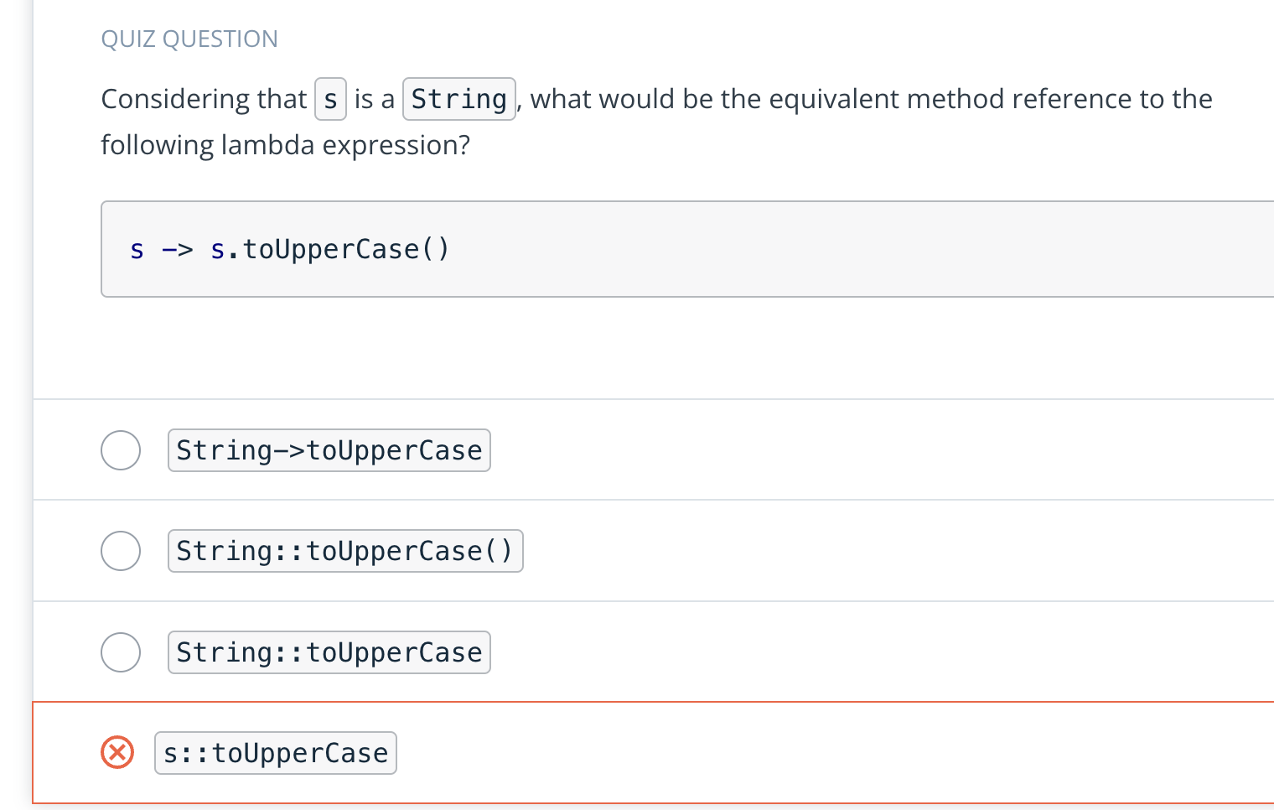
  - String::toUpperCase does the same thing as s -> s.toUpperCase().
  - Although method references can be obtained from objects, here the s object is not defined.

Stream API
Java Collection APIs
Can use ForEach to add all elements to a collection ← but can use collector for that sort of things

Questions:
A stream pipeline consists of one or more intermediate operations, followed by a terminal operation.
- 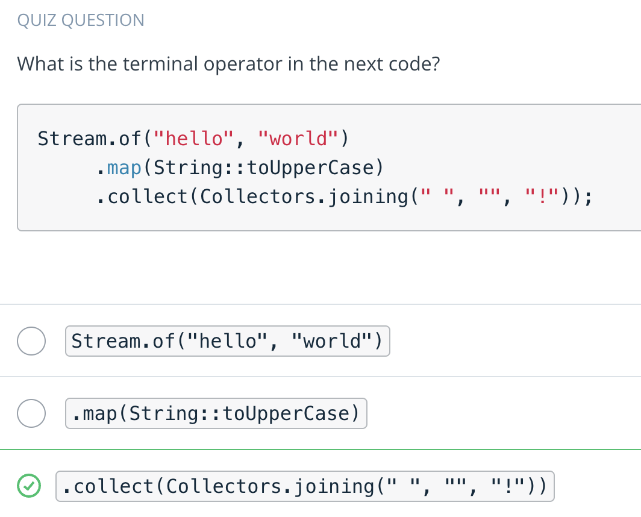
  - .collect(..) repackages the elements of the stream into some data structure or apply additional logic to them. In this case, it's joining the String elements of the stream to create a new String.
- 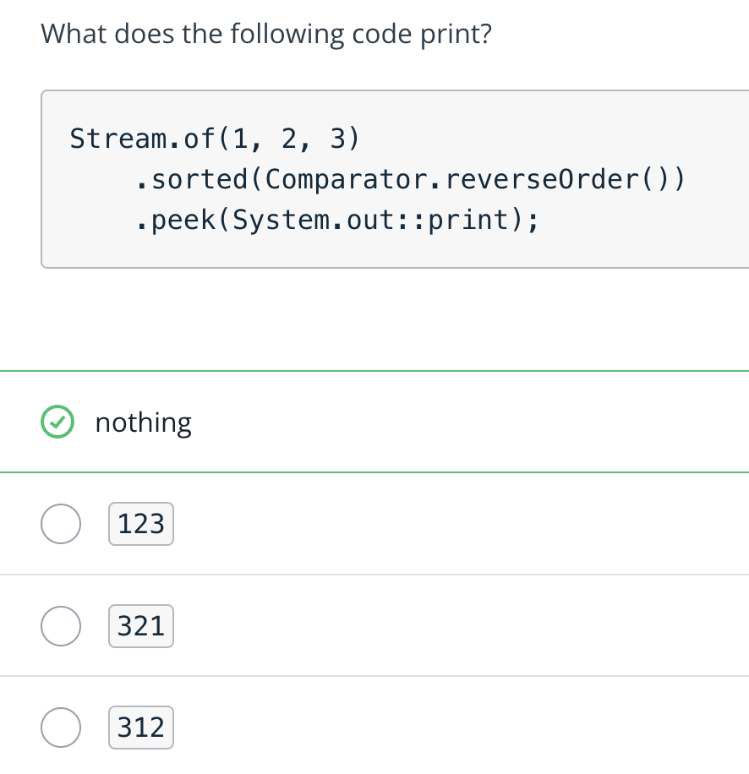
  - Streams are lazily evaluated, meaning no computation happens until the terminal operator is called.

Stream API: Collectors
What is a Collector?
A Collector is a terminal stream operation that accumulates stream elements into a container.

(Insert pic)

Pass a method reference to groupingBy

Quiz questions:
